**Outputs for Revroll Company SQL queries.**

**Question 1 Question 2**

**Question 3 Question 4**

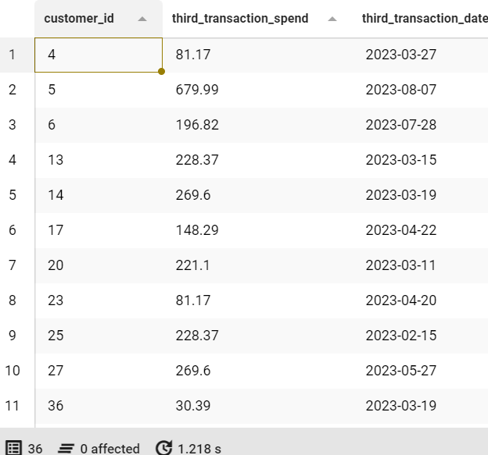**

**Question 5 Question 6**

